BANK
MANAGEMENT SYSTEM

Course: Programming in C
Submitted By: Vani Gupta 590022116 B-54
Sanchita Khaira 590023918 B-54

Abstract

The Bank Account Management System is a menu-driven C program that simulates basic banking operations such as opening an account, depositing and withdrawing money, checking balance, viewing transaction history, and identifying defaulters.
The system uses file handling to store data persistently, ensuring that every customer's information is saved in an individual .dat file.
This project demonstrates the use of structures, functions, file operations, switch-case, and string handling in the C language while providing a realistic and modular solution to basic banking management tasks.

Problem Definition

Banks require a simple computer-based system to manage customer accounts without using a database.
The system should:
1. Allow new users to create an account.
2. Store customer data permanently.
3. Allow secure deposits & withdrawals with validation.
4. Maintain complete transaction history.
5. Identify defaulters (customers below minimum balance).
6. Enable account closure.
7. Provide basic enquiry and balance-check services.

The challenge is to design a menu-based C program that performs all of these operations accurately using file handling.

System Design

Algorithms

Algorithm: Open Account
1. Start
2. Ask user for unique ID
3. Ask for name
4. Set balance = 0
5. Set transactioncount = 0
6. Create file account_<id>.dat
7. Write structure data to file
8. End

Algorithm: Deposit Money
1. Start
2. Ask for account ID
3. Load file
4. Validate file exists
5. Read amount
6. Check if amount between 500–100000
7. Add to balance
8. Append transaction to history
9. Save file
10. End

Algorithm: Identify Defaulters
1. Start
2. Input minimum balance
3. Loop through ID = 1 to 9999
4. For each ID, try loading account
5. If exists and balance < min: display
6. End

Implementation Details

Technologies Used
Programming Language: C
Compiler: GCC
Concepts Used:
Structures
File handling (binary .dat files)
String functions (strcat, sprintf)
Modular programming

Important Code Snippets

Structure Definition
typedef struct
{
int uniqueid;
char name[50];
float balance;
char transactionhistory[1000];
int transactioncount;
} Account;
Saving an Account
void saveaccount(Account acc)
{
char filename[30];
sprintf(filename, "account_%d.dat", acc.uniqueid);
FILE *file = fopen(filename, "wb");
fwrite(&acc, sizeof(Account), 1, file);
fclose(file);
}
Deposit Money Logic
acc.balance += amount;
sprintf(entry, "Deposited: %.2f\n", amount);
strncat(acc.transactionhistory, entry, sizeof(acc.transactionhistory) - strlen(acc.transactionhistory) - 1);
Identifying Defaulters
for (int id = 1; id <= 9999; id++) {
Account acc = loadaccount(id);
if (acc.uniqueid != 0 && acc.balance < minBalance) {
printf("ID: %d | Name: %s | Balance: %.2f\n",
acc.uniqueid, acc.name, acc.balance);
}
}

Testing & Results
Test Case 1: Open Account
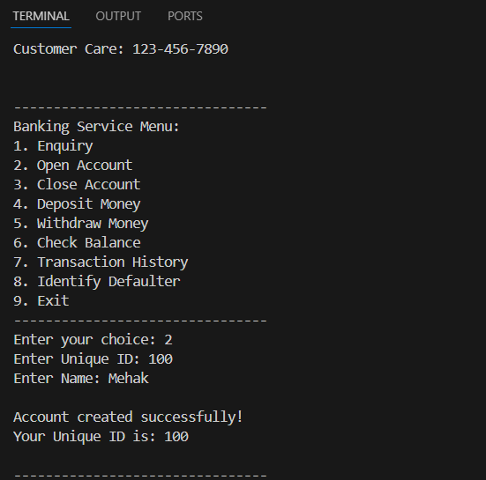
Test Case 2: Deposit Money
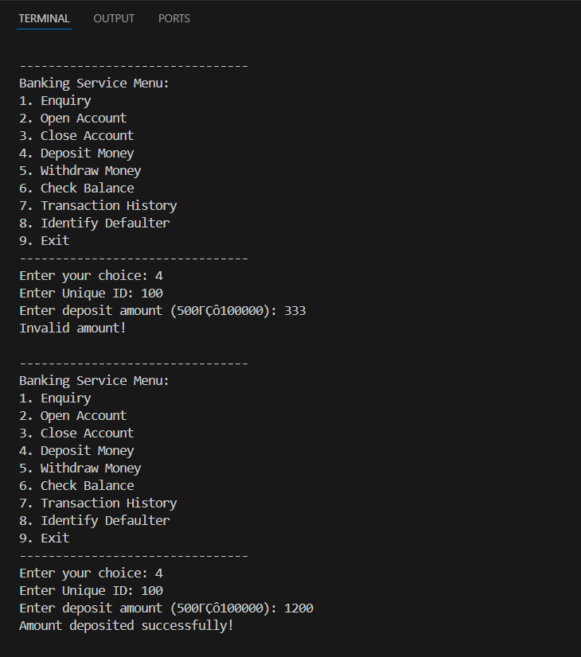
Test Case 3: Withdraw Money
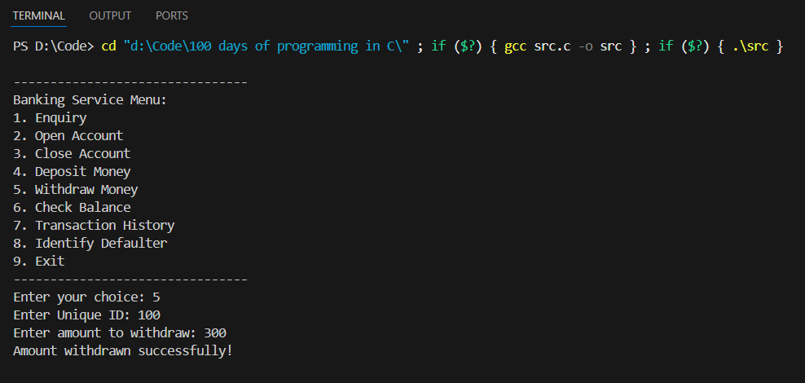
Test Case 4: Transaction History
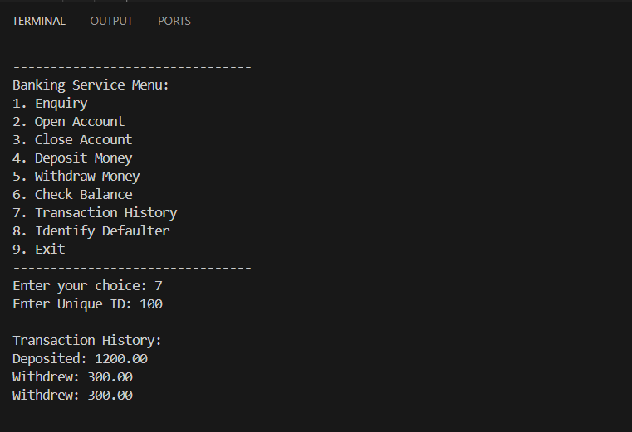

Conclusion & Future Work

Conclusion

This project successfully simulates real banking operations using C programming and file handling.
It demonstrates persistent storage, modularity, menu-driven interaction, and transaction tracking.

Future Enhancements

Add password security for accounts
Add interest calculation
Add admin login
Export transaction history as a text file
Replace files with a database (SQLite)

References

Let Us C – Yashavant Kanetkar
ANSI C Documentation
Online C reference documentation

